
GAYAZA JUNIOR SCHOOL
ENGLISH FOR PRIMARY TWO 2020

NAME: ______________________STREAM______
- Fill in the missing letters.
- fl___g
- be___l
- b__nch
- Write correctly.
- irahc __________________
- ormbo _________________
- ryalbir _________________
3. Answer in full sentences.

a) Are these desks?
____________________________________
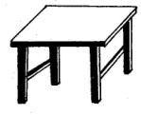
b) Is this a chair?
____________________________________
c) Are these school flags?
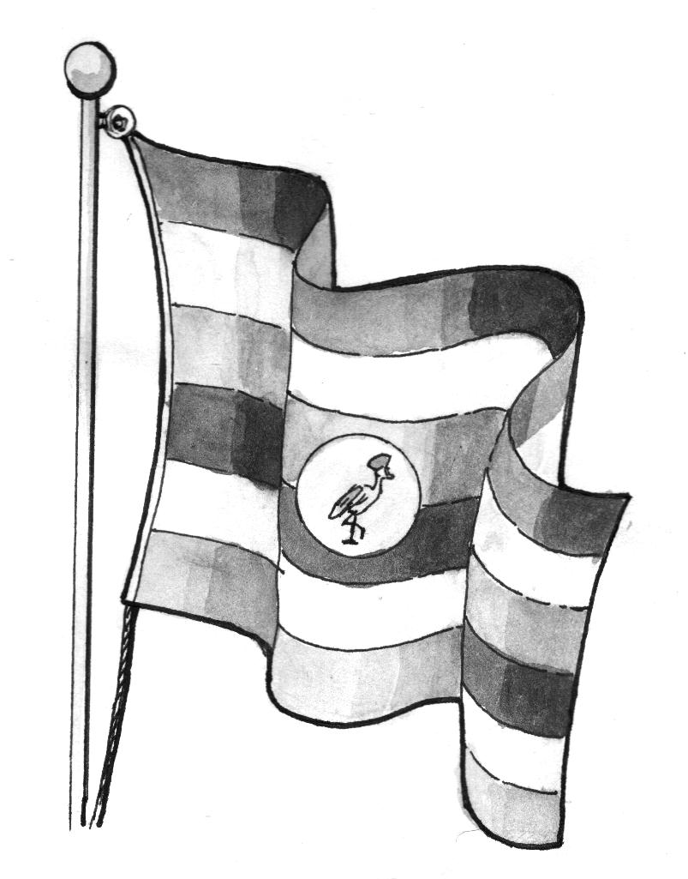
- Are these school flags?

- Is this a school badge?

4. Make small words
Uniform __________________________
Teacher __________________________
5. Join to make one word.
a) head + teacher _____________________
b) cup + board _____________________
c) sign + post _____________________
6. Fill in the correct preposition.
a) Don’t lean ______________the wall.
b) Paul died _______________cholera.
c) What are you interested______?
7. Name the picture.
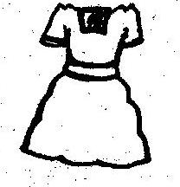
G.J.S
P.O BOX
_____________ ____________
8. Read and draw the pictures.
The ball is under the bed.

Two balls are flying over the tree.

9. Fill in the correct plural forms.
a) _________should be kept clean (book)
b) Where are the______________? (puppy)
c) The __________ are very heavy. (box)
d) __________ enjoy swinging on trees. (monkey)
10. Who am i?
a) Iam a tool, the police use me to keep peace.
I am a ____________
b) I am a person, who takes people’s things without permission. I am a _____________
c) I am a schoolsymbol. Pupils put me on when going to school. I am a _____________

11. Underline the correct plural.
a) leaf: leaves, leafves, leafs.
b) chief: chieves, chiefves, chiefs.
c) furniture: furnitures, furniture.
d) tooth: tooths, toothes, teeth.
e) Fruit: fruits, fruit, fruites.

12. Make sentences.
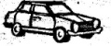
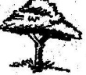
- ____________________________

(b) ____________________________


(c) ____________________________

13. Use a full stop (.) a question mark (?) and capital letters.
a) was ruth sick last Monday
_______________________________________
b) how old is Deborah
_______________________________________
c) i live at gayaza
_______________________________________
d) this is a tree.
_______________________________________
14. Form sentences using these words.
a) aunt_________________________________
b) son_________________________________
c) brother______________________________
d) mother _____________________________
15. Fill in the correct word.
a) The daughter of your mother and father is a
_________________________
b) A _________________is the mother of your mother or father.
16. Choose the correct word from the box to complete the sentences.
(fisherman, carpenter, fishmonger, doctor)
a) I am a ____________________, I treat sick people in the hospital.
b) I go to the lake. I catch fish with nets
I am a ___________________________
c) I make chairs, beds, tables and cupboards from wood. I am a _______________________________
d) Punctuate correctly.
i) I bought bread cakes and chocolates last Monday.
_______________________________________
ii) Where is james bag
_______________________________________
iii) moses cleaned the teachers table yesterday
_______________________________________
17. Write in short.
Let us _____________ Teacher ____________
Can not ____________ Wednesday __________
Doctor ____________ October ____________
18. Give one word for many.
a) tables, chairs, desks are___________________
b) pawpaws, oranges are_____________________
c) red, blue, pink, black are___________________
d) Tuesday, Thursday, Monday are______________
19. Join sentences using “and”
a) Mary has a dress. Anna has a dress.
_______________________________________
b) Ali went to the shop. Ali bought a match box.
_______________________________________
c) Mark is a good boy. Richard is a good boy.
_______________________________________
d) Tim has a shirt. Tim has a coat.
_______________________________________
e) Ivan was absent. Rose was absent.
_______________________________________
20. Use ‘was’ or ‘were’.
a) The monkeys ____________chased away by the
dog.
b) A bicycle _________repaired yesterday.
c) ________you treated by a doctor?
d) ________he taken to school by his mother?
21. Read the story and answer the questions in full sentences.

School symbols are things that make a school different from others. These include, school uniforms, school address, school flag, school anthem and many others, school symbols have different uses.
A school uniform makes children different and smart: a school signpost directs people to the school and a school prayer helps the pupils to trust in God.
Questions
- What are school symbols?
_______________________________________
- Write any two school symbols in the story.
i) ___________________ii) ________________
3. What makes children different from others?
_______________________________________
4. What is a signpost used for?
________________________________________
5. What helps the pupils to trust God?
________________________________________
6. Give a title to the story.
________________________________________
22. Arrange the jumbled sentences to make a story.
a) He took the soda.
b) He went to the shop.
c) Peter picked money.
d) He opened it at once.
e) He bought a bottle of soda.
Good story
a) _______________________________________
b) _______________________________________
c) _______________________________________
d) _______________________________________
e) _______________________________________
23. Complete the story correctly.

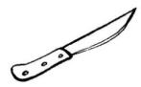
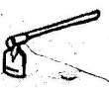
Kayanda lives in a small _________near a big farm. He goes to dig with his ________and a ___________ . There are a lot of crops on his_____
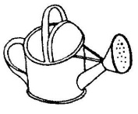
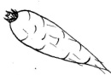
He also keeps some domestic animals. He waters his________ and ___________every
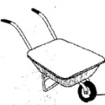
morning with a ___________________ . . When the crops are ready, he harvests them during the______ season and carries them on a ________ home.

24. Re-arrange these sentences to forms a correct
story.
a) She sent Tom and Jerry to the market.
b) They bought rice and meat.
c) Mummy wanted to prepare lunch.
d) And they had a wonderful lunch.
e) She prepared the food.
A correct story.
a) _______________________________________
b) _______________________________________
c) _______________________________________
d) _______________________________________
e) _______________________________________

25. Join A to B and write a correct sentence.
 | A | B
a | May I have a kilogram | of biscuits
b | She bought a dozen | of food
c | Bring that packet | of books
d | Those are two metres | of cloth
e | He has a dish | of sugar

26. Read the dialogue and answer the questions
about it.

Mawa : Good morning, Otti.
Otti : Good morning, Mawa.
Mawa : Where do you play from?
Otti : We play from the field.
What abaout you?
Mawa: we play from the main hall because it is a rainy season.
Questions.
- At what time did the dialogue take place?
_____________________________________
- Who spoke first?
____________________________________
- How many people are speaking?
_____________________________________
- Who plays from the field?
_____________________________________
- Why does Mawa play from the main hall?
___________________________________
- Who spoke lastly?
___________________________________

GJS LITERACY I PRIMARY TWO

HUMAN BODY AND HEALTH

Name: ______________________stream_______

- Write any two body senses.
__________________________________
- Name the sense organ for tasting.
___________________________________
3. Name the parts of the arm below.
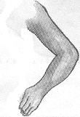

4. Write any two body exercises.
i) ____________________________
ii) ____________________________
6. What is sanitation?
_______________________________________
7. Draw and name any four things used to promote sanitation.

8. How do we keep places clean?
_______________________________________
9. Why is it good to keep places clean?
_______________________________________
10. What do we call the general cleanliness of our body and the things we use?
_______________________________________
11. State any two ways of promoting personal hygiene
i) _____________________________
ii) ______________________________
12. Why do we keep our bodies clean?
_______________________________________
13. Name these things used to keep our bodies clean.
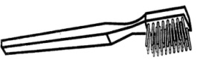 | 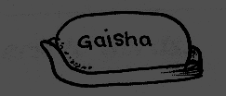 | 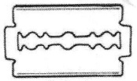 | 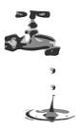

14. Why do we iron clothes?
_______________________________________
15. Write out the common diseases.
Malaria. Polio, measles, matchbox, rake, typhoid, posho.
- __________________________
- __________________________
- __________________________
16. When should we brush our teeth?
_______________________________________
17. State any one cause of common accidents.
_______________________________________
18. How can one cause common diseases?
_______________________________________
19. What do we call the way of protecting our bodies from some diseases by introducing vaccines into the body.____________________________________
20. Name the medicine used to immunize.
____________________________________
(vaccine, vaccine)

21. Tick the immunisable disease only.
Polio, measles, malaria, pneumonia, cough, diarrhea, flu, turbeculosis.

END

GJS LITERACY I PRIMARY TWO

1. What is a school?__________________________
______________________________________
2. Why do children go to school?
_______________________________________
3. Who heads a school?
_______________________________________
4. Write any two things used to clean your school.
i) ___________________________
ii) ___________________________
5. In which district is your school found?
_______________________________________
6. What name is given to the things that make a school look different from other schools?
_______________________________________
7. State any two school symbols.
_______________________________________
8. How is a school signpost useful to a school.
_______________________________________
9. Why is it good to wear school uniforms?
_______________________________________
10. Name any two groups of people who wear uniforms.
______________________________________
11. Why does a school need teachers?
______________________________________
12. How can we keep our school clean? (give two)
____________________________________
____________________________________
13. Match people to their roles.
Headteacher takes care of children
Matron heads a school.
Cook collects school fees
Bursar cooks food
14. Name any two groups of people who helps a school to get its needs?
i)___________________ii)__________________
15. Write any two school needs.
_____________________ _______________
16. How do parents help a school to get its needs?
_______________________________________
17. Who is a neighbor?
_________________________________________
18. Give any two benefits of the school from the neighbor.
(i) _________________________
(ii) _________________________
19. How does the neighborhood benefit from the school.
(i) __________________________
(ii) __________________________
20. Give any two problems between the school and the neighbourhood.
(i) ___________________________
(ii) __________________________
OUR HOME AND COMMUNITY
- What is a home?
____________________________________
- What is a family?
____________________________________
- Which two people start up a family?
___________________________
___________________________
- State the two types of families.
___________________________
___________________________
- Apart from a mother, father and their own children, state any other two people found in an extended family.
________________________
________________________
- What are basic needs?
- Name and draw three basic needs.

- What is a community?
____________________________________
- Name the smallest community
______________________
- Give any two importance places found in our school community.
- ________________________
- ________________________
- Write any three people found in our community.
- ____________________
- ____________________
- Complete correctly
- A father to your mother is your? _________
- A daughter to your father is your? _____________
- A son to your brother or sister is your? _____________
- If I am a girl ,My father calls me _________
- If I am a boy ,My grandmother calls me _____________
- Fill in the missing letters.
- T__ __ cher
- Nur __ __
- Carpen __ __ r
- Bur __ __ r
- Match people to their community.
Doctor market community
Priest school community
Teacher hospital community
Market vender church community

END

GJS MATHEMATICS FOR PRIMARY TWO

NAME:________________________STREAM_____
- What is a set?
_______________________________________
2. Join these sets.

S s
s

S
s
+ =

3. Separate these sets.

- =

4. Form new sets and count members.
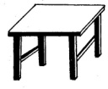

__________

__________
__________
5. Name these sets.
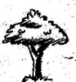
________________________

________________________

6. Draw these sets.
a) A set of three stools.

b) A set of five vowel letters.


7. What is an empty set?

8. A B

Set B has __________members
Set A has __________members
Set A has __________more than set B
How many members are there altogether?

9. Match correctly.
5
3
8
Elephant
Tiger
Cow



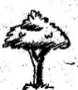
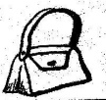

10. E F G H

Arrange the sets starting with the biggest.
Set ___________comes first.
Set ___________comes second.
Set ___________comes third.
Set _________comes fourth.
11. Count and write the figures in words.

a) There are _________cups


b) There are________books.

c)
There are ________boxes.

d) There are________pencils.

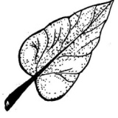
e) This is ________leaf.

12. What is the place value of the underlined numbers?
a) 2 3 4 c) 1 4 3

b) 6 2 4 d) 3 0 9

13a) Which numbers has been represented on the
abacus?
H T O

14. Draw hundreds, tens and ones using the abacus.
a) 3 2

b) 1 0 5

c) 9

15. Fill in hundreds, tens and ones.
a) ____hundreds, ______tens, _____ones = 20
b) 314 = ___hundreds, ___tens, ____ones
c)
____tens, ____ones = ____
16. Expand these numbers.
a) 63 = _____ + ____
b) 925 = ____ + ____
c) 204 = ____ + ____
17. What number has been expanded?
a) 400 + 10 + 9 = _______
b) 800 + 50 + 0 = _______
c) 50 + 2 =_____
18. Write the following in words.
a) 8 ____________________
b) 20 ___________________
c) 100____________________
d) 194 _____________________
19. Write these number words in figures.
a) Nine hundred seventy six

b) six hundred sixty six

c) 3 4
+ 2 6

d) 974 + 23

e) Primary one class has 130 pupils and primary two class has 256 pupils. How many pupils are there altogether?

f) Ten rulers plus six rulers equals_____rulers.

g) What is the sum of ten and four?
21. Take away
a) 8 – 3 = _____
b) 20 – 11 = ____
c) T O
7 8
- 4 8

d) Peter had 890 mangoes. He sold 670 mangoes to Paul. How many mangoes did he remain with?

22. Multiply.
a) 8 x 2 b) 1 3
x 3

c) If one chair has 4 legs. How many legs has 5 chairs have?


d)

How many eggs are in these nests?
_____ x ____ = 12 eggs.
c) Multiply: 3 x 0 = _____

23. What is the shaded fraction?
a)
= __________

b)
= _____________

24. Add these fractions.
a) 3 + 7 = _________
10 10 = _________

b) 6 + 1 = _____
8 8 = _____

25. Subtract the fractions.
a) 7 - 4 = _____
10 10 = _____

b) 6 - 4 = ____
13 13 = ____

23. Add using a numberline.
a) 3 + 4 = ____

b) 2 + 7 = ____

24. Use a numberline to take away.
a) 8 - 3 = ____
25. Arrange from the biggest to the smallest.
a) 70, 50, 30, 40
___________________________________
b) 3, 1, 9, 4, 2
___________________________________
27. Find the missing numbers.
i) 1, 2, 3, 4, 5, 6, 7, 8, 9, ___
ii) 10, 20, 30, 40, 50, ___, ___
iii) 5, 10, 15, 20, 25 ___, ___
iv) 20th, 21st , ____23rd , ____, 25th

END

